

KAUNAS UNIVERSITY OF TECHNOLOGY

FACULTY OF INFORMATICS

T120B166 Development of Computer Games and Interactive Applications

***“S5TTSI”***

|  |
| --- |
| *IFF-9/3 Danielius Mozūras*  *IFIN-0/2 Kornelijus Ulevičius* |
|  |
| Date: *2022.03.10* |

Kaunas, 2022

Tables of Contents

Tables of Images 3

Table of Tables/functions 4

Work Distribution Table: 5

Description of Your Game 5

Laboratory work #1 6

List of tasks 6

Solution 6

Task #1. *First person shooting* 6

Task #2. *Player controls* 7

Task #3. *Enemies* 8

Task #4. *Terrain* 9

Task #5. *Menu* 10

Laboratory work #2 12

List of tasks 12

Solution 12

Task #1. *Health and armor bars* 12

Task #2. *Sounds effects* 13

Task #3. *Enemy AI chasing player* 13

Task #4. *Killing Enemy AI with visible bullets* 14

Task #5. Gun shooting like Bow 16

List of tasks 18

Solution 18

Task #1. *Zombie attacking/walking/Spawning* 18

Task #2. *Ammo UI* 20

Task #3. *Inventory* 21

Task #4. *Music slider* 24

Task #5. *Collectable Items* 24

Task #5. *High Score in PlayerRefs* 25

User's manual 27

Literature list 29

ANNEX 30

# **Tables of Images**

Figure 1. Shooting screenshot #1 6

Figure 2. Movement screenshot #2 7

Figure 3. Enemy screenshot #3 9

Figure 4 Terrain screenshot #1 10

Figure 5 Menu screenshot #1 10

Figure 6 Menu screenshot #2 11

Figure 7. Screenshot #1 12

Figure 8. Screenshot #2 13

Figure 9. Screenshot #3 13

Figure 10. Screenshot #1 15

Figure 11. Screenshot #2 16

Figure 12. Screenshot #3 16

Figure 13. Screenshot #5 18

Figure 14. Screenshot #5 18

# **Table of Tables/functions**

Table 1. Title of fragment #1 7

Table 2. Title of fragment #2 8

Table 3. Title of fragment #3 9

Table 1. Title of fragment #1 9

Table 2. Title of fragment #2 10

Table 3. Title of fragment #3 11

Table 1. Title of fragment #1 12

Table 2. Title of fragment #2 13

Table 3. Title of fragment #3 14

# **Work Distribution Table:**

|  |  |
| --- | --- |
| ***Name/Surname*** | ***Description of game development part*** |
| *Danielius Mozūras* | *scripts, UI, physics, prefabs, enemies* |
| *Kornelijus Ulevičius* | *terrain, UI, textures, sounds, prefabs, scenes.* |

# **Description of Your Game**

Description of Your Game.

1. 3D or 2D? *3D*
2. What type is your game? *First-person shooter*
3. What genre is your game? *Action*
4. Platforms (mobile, PC or both?) *PC*
5. Scenario Description. You wake up in your house surrounded by strange creatures, your goal is to escape the house, the only way to do that is to eradicate the strange creatures and find your way to the exit.

**Laboratory work #1**

**List of tasks** (main functionality of your project)

1. First person shooting
2. Player controls
3. Enemies
4. Terrain
5. Menu

# **Solution**

## **Task #1. *First person shooting***

We implemented the basic mechanics of shooting. The gun shoots bullets that are for now invisible, but register on hit with other objects. Our bullets do 10 damage.

Description of the implementation (3-5 sentences).

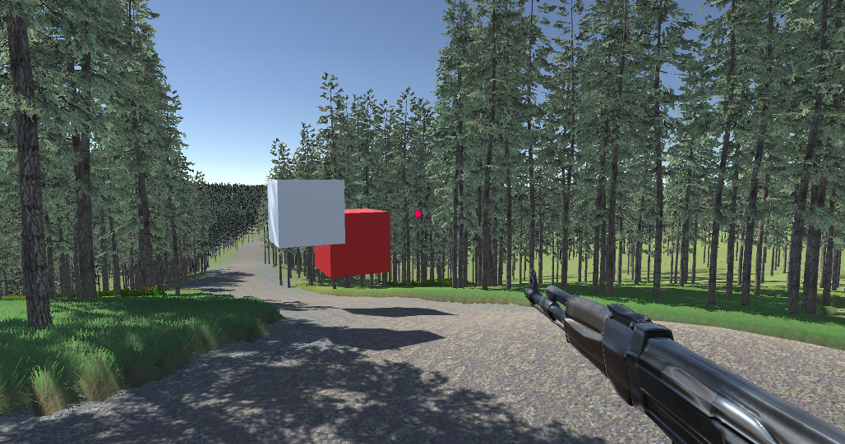

Figure 1. Shooting screenshot #1

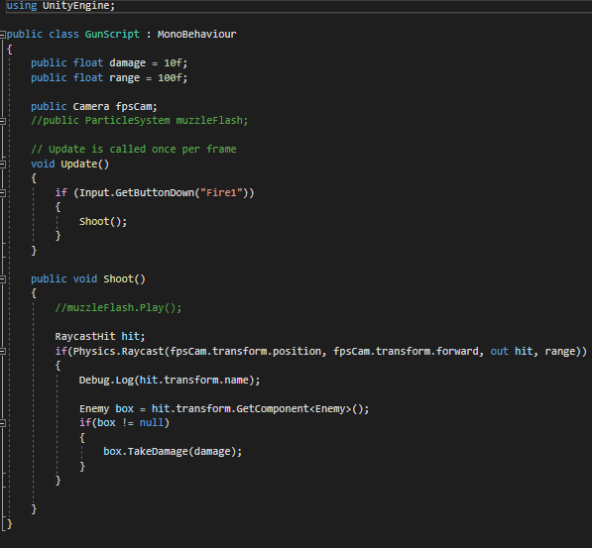

Table 1. Title of fragment #1

## **Task #2. *Player controls***

We created a first person player controller. The player can do the basic actions of moving forward, backward, left and right, jump, look around, shoot.

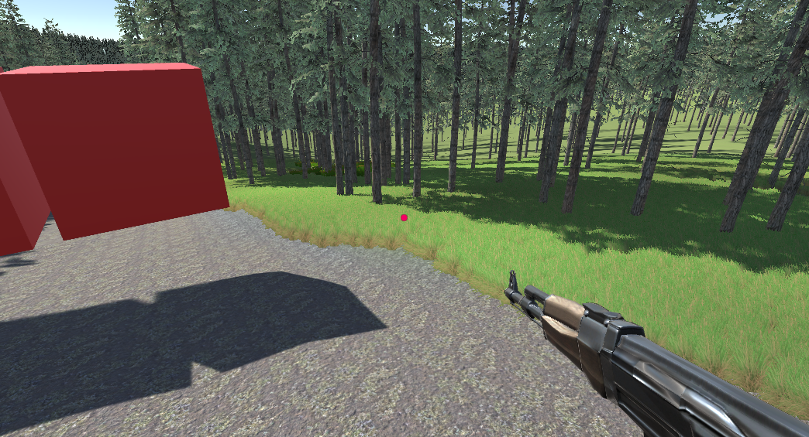

Figure 2. Movement screenshot #2

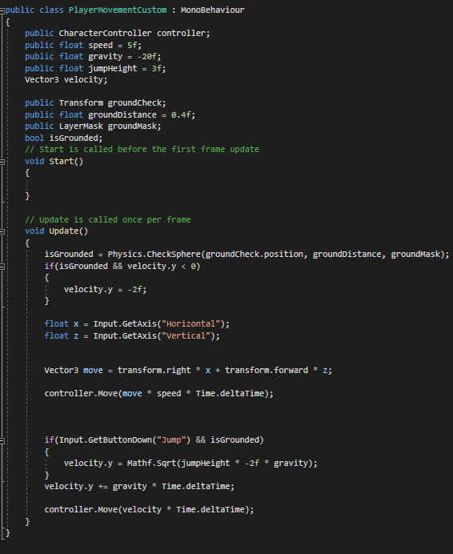

Table 2. Player Controller #2

## **Task #3. *Enemies***

For now our enemies are represented by red cubes. The cubes do not have movement mechanics yet, but they have a health of 50, which means it takes 5 bullets to kill them. After they are killed they are destroyed.

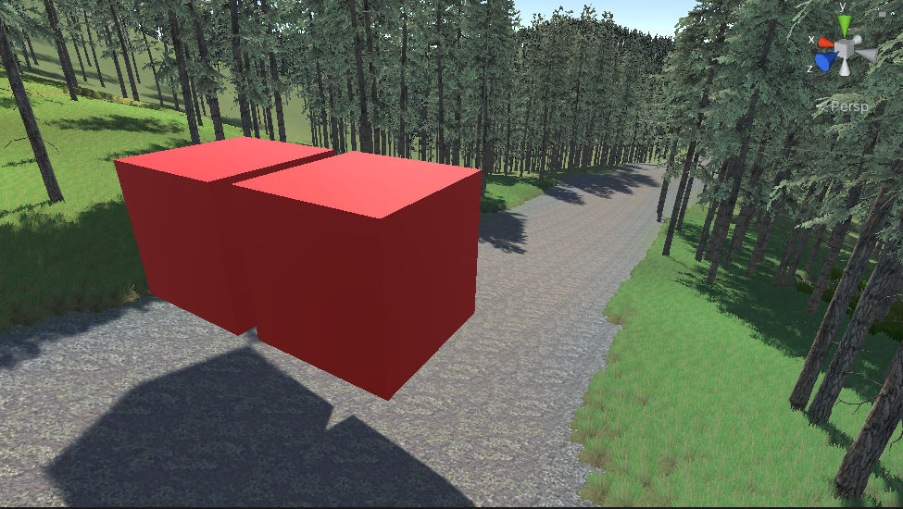

Figure 3. Enemy screenshot #3

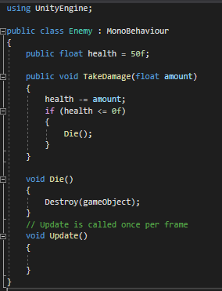

## **Task #4. *Terrain***

We added a very wide and polished out terrain. The terrain is hilly and with a lot of trees and other aesthetic details like grass flowers. We added a cabin in our map

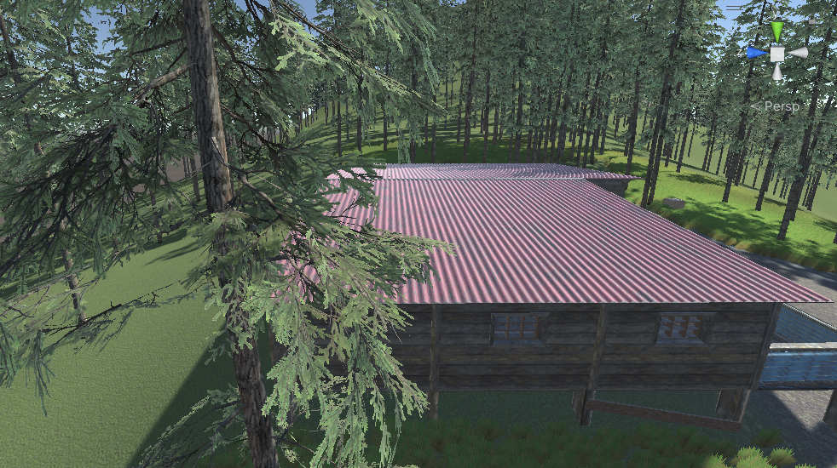

Figure 4 Terrain screenshot #1

## **Task #5. *Menu***

We added a game menu, with the options: “start” “options” (music volume, effect volume) “exit”. After you press “start” and are in the game you can press escape to pause the game and see the pause menu in which you have the options: “resume” “menu” “exit.

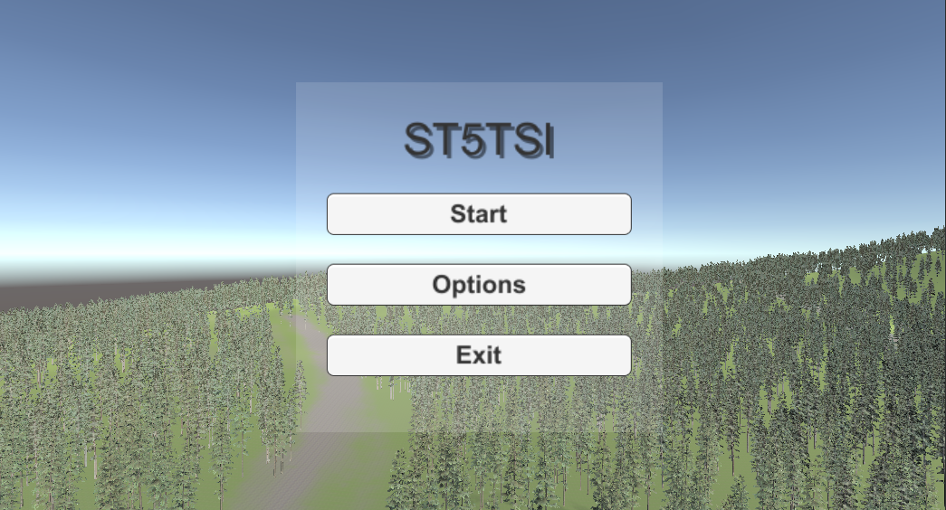

Figure 5 Menu screenshot #1

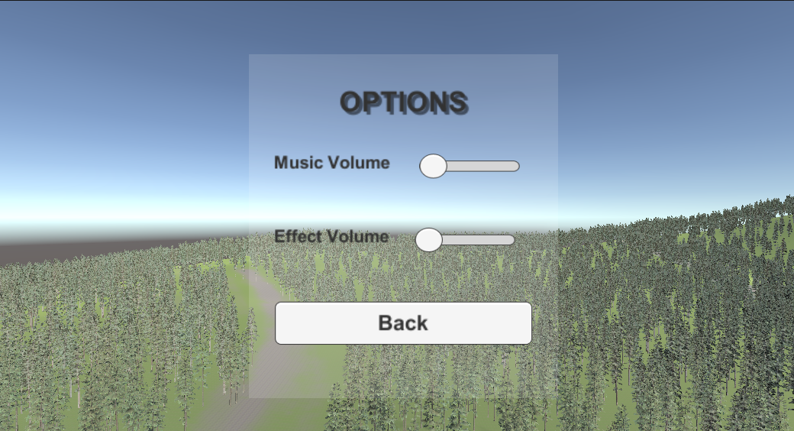

Figure 6 Menu screenshot #2

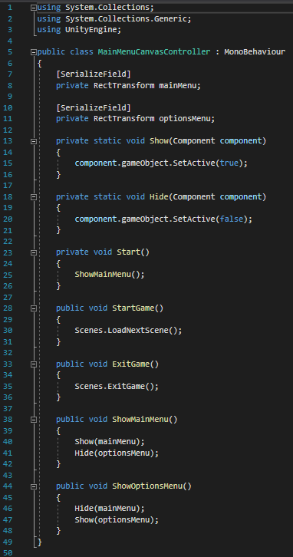

Table 3. Title of fragment #3

**Laboratory work #2**

**List of tasks** (main functionality of your project)

1. Health and armors bars
2. Sound effects
3. Enemy AI chasing player
4. Killing Enemy AI with visible bullets
5. Gun shooting like bow

# **Solution**

## **Task #1. *Health and armor bars***

Added a health bar and armor bar. Before the enemies can injure you they first deal damage to your armor and only after it depletes you start taking damage to your health.

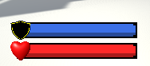

Figure 7. Screenshot #1

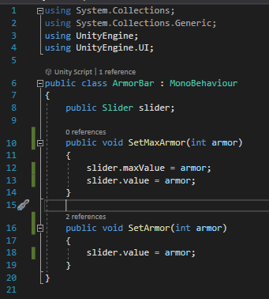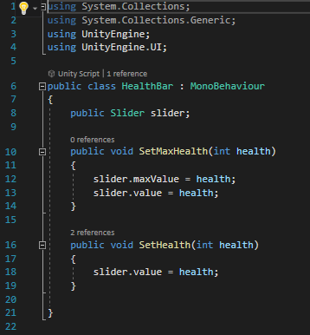

Table 4. Title of fragment #1

## **Task #2. *Sounds effects***

Added sound effects for different triggers. We added a general background music, and sounds for armor breaking, getting injured and dying.

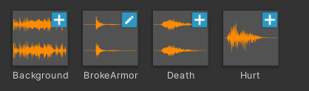

Figure 8. Screenshot #2

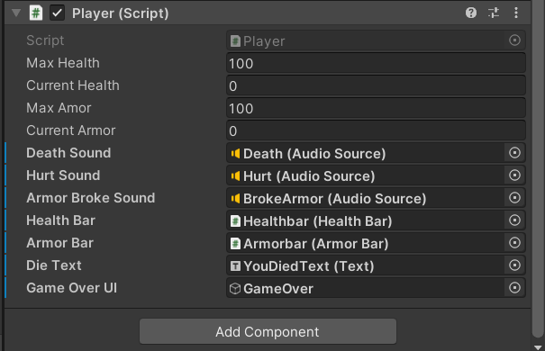

Table 5. Title of fragment #2

## **Task #3. *Enemy AI chasing player***

Created enemy AI agent that patrols around randomly around the walkable area when the player is outside their sight range, and starts chasing the player when the player is in sight range

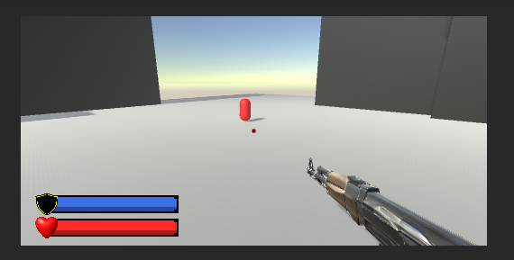

Figure 9. Screenshot #3

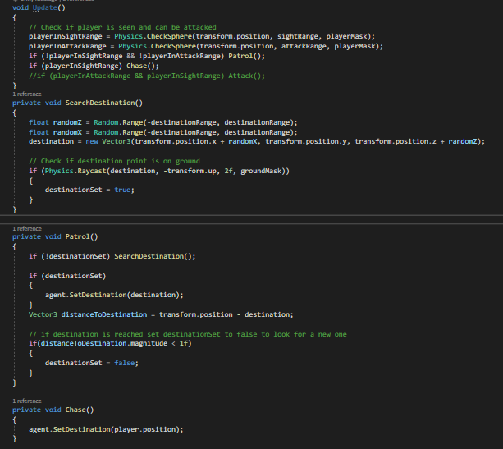

Table 6. Title of fragment #3

## **Task #4. *Killing Enemy AI with visible bullets***

Added visible bullets that deal damage to enemy AI agents and when their health reaches 0 or less they die. The bullet amount is also limited and you can reload by pressing “R”

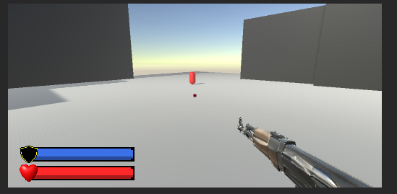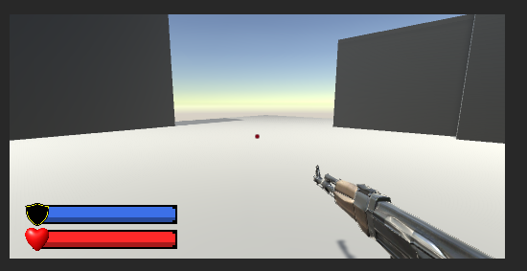

Figure 9. Screenshot #3

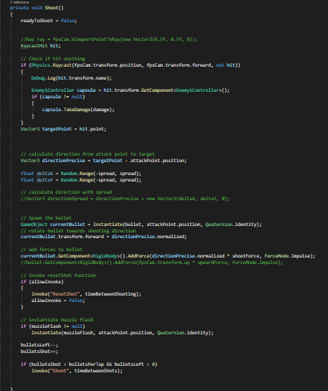

Table 6. Title of fragment #3

## **Task #5. Gun shooting like Bow**

Added gun modifiers which let shooting like bow. Shot power depends on how long you press wheel button. Bullet have “rigidbody” component witch let flies in form of hyperbolism.

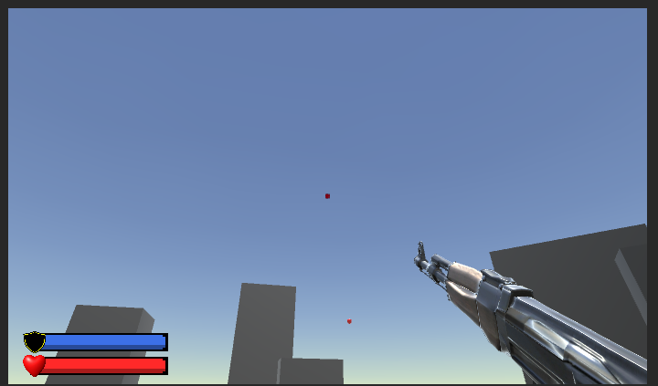

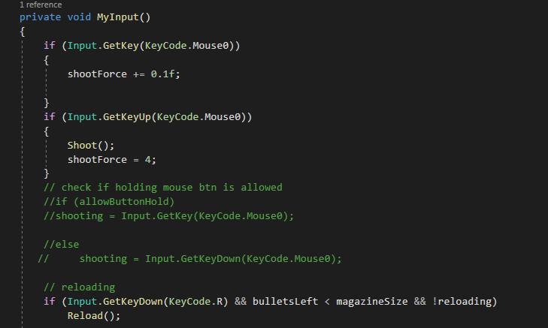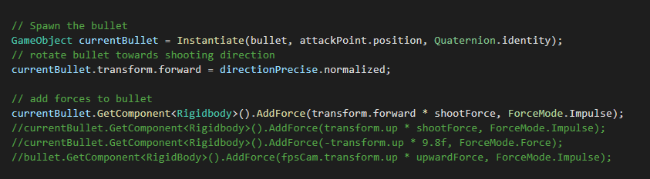**Laboratory work #3**

**List of tasks** (main functionality of your project)

1. Zombie attacking/walking
2. Ammo UI
3. Inventory
4. Music slider

# **Solution**

## **Task #1. *Zombie attacking/walking/Spawning***

We added A Zombie model for our enemy with zombie specific animations for walking, running, attacking and dying. The zombie enemy uses NavMeshAgent to seek the player.

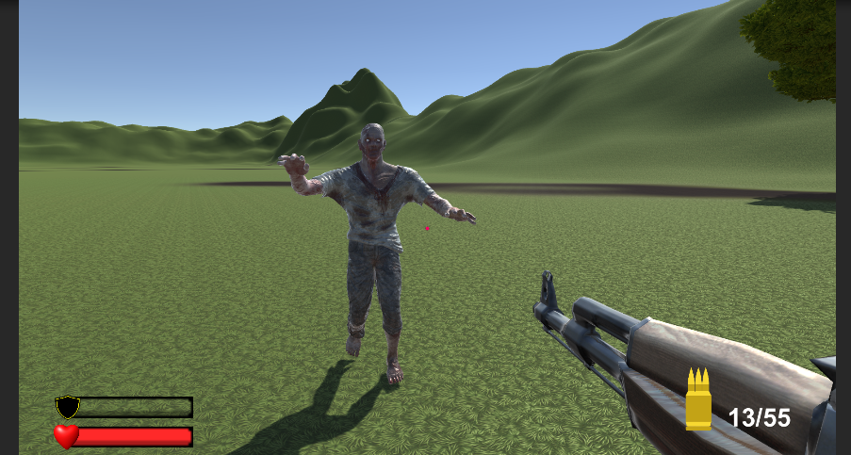

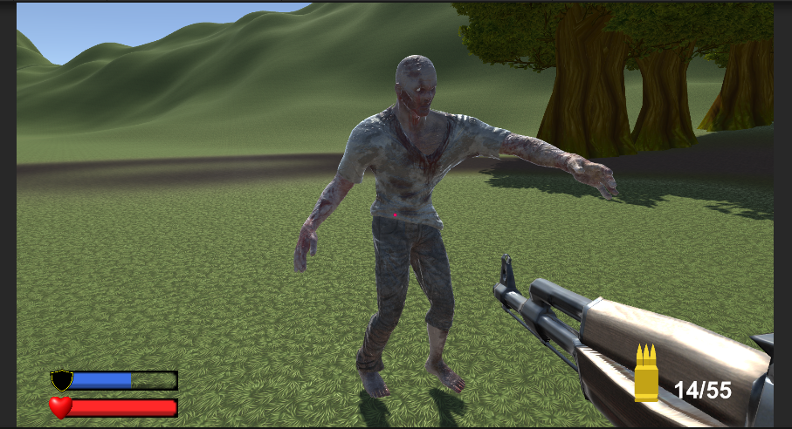

Figure 10. Screenshot #1

Table 7. Title of fragment #1

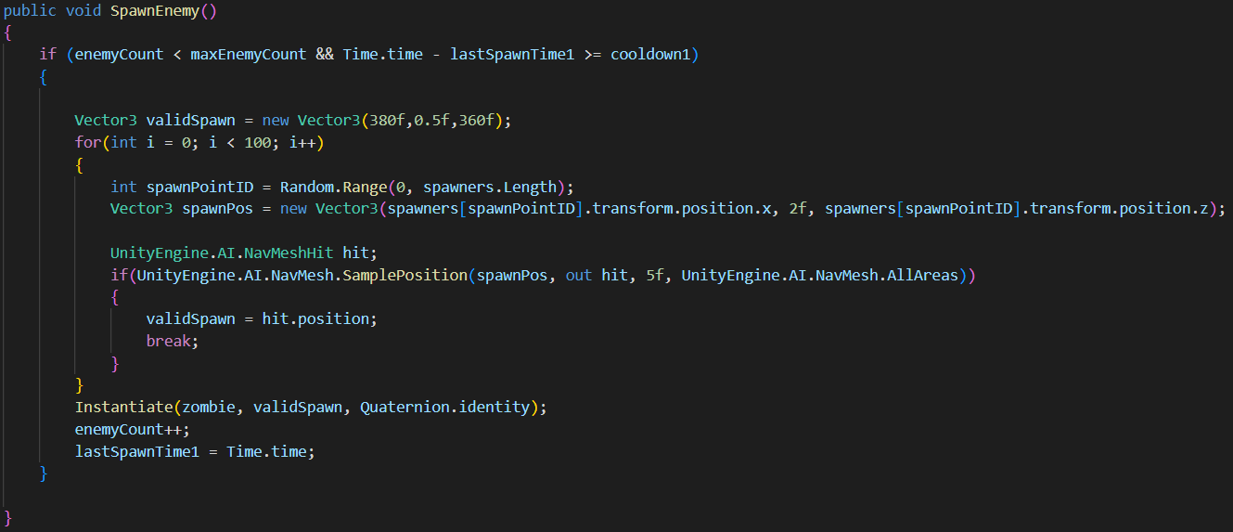

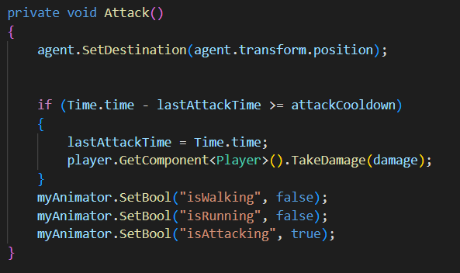

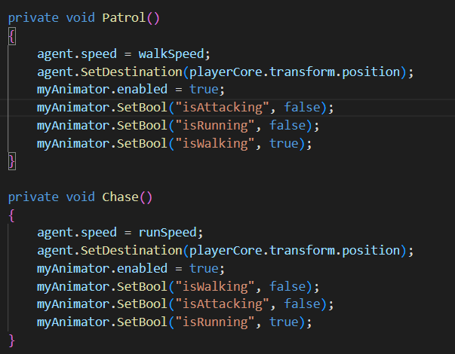

## **Task #2. *Ammo UI***

Description of implementation (3-5 sentences). The screen shows how many bullets are left in total and how many are in the magazine. When the magazine is being loaded, reloading text appears on the screen.

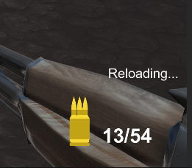

Figure 11. Screenshot #2

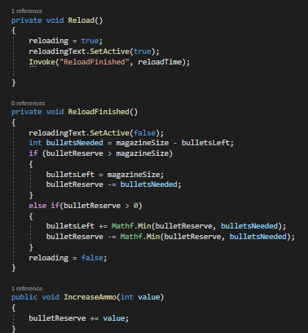

Table 8. Title of fragment #2

## **Task #3. *Inventory***

Description of implementation (3-5 sentences). Pressing “e” button opens inventory. Also, you can close it using same button “e”. As well items can be picked and placed in inventory. When an item is placed in the inventory item name and icon appear.

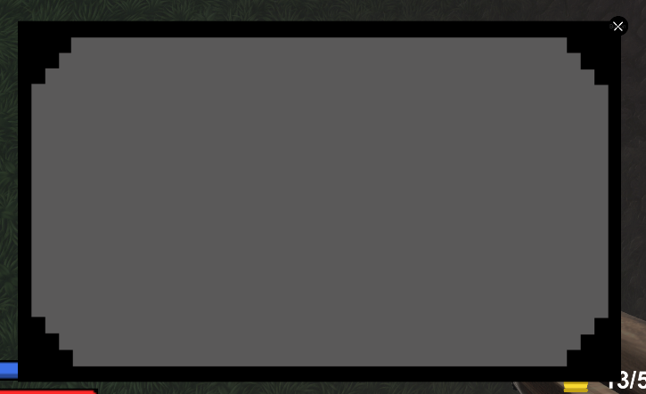

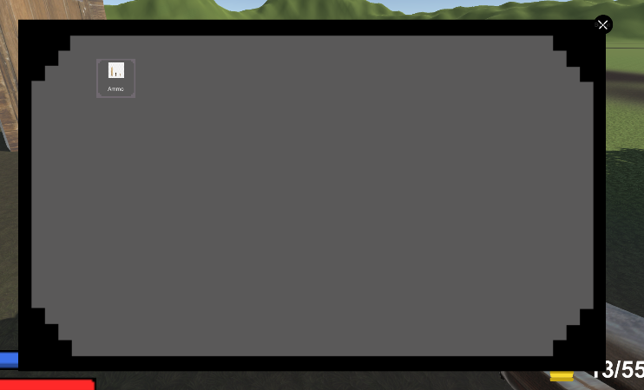

Figure 12. Screenshot #3

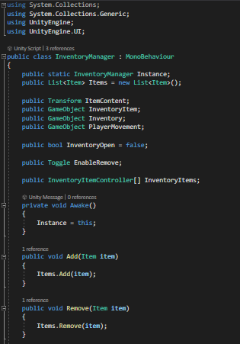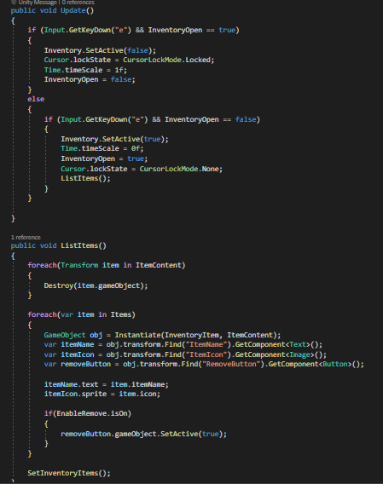

Table 9. Title of fragment #3

## **Task #4. *Music slider***

We added a slider to control the music volume in the game.

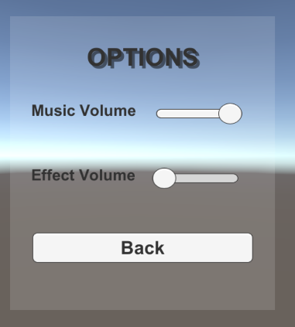

## **Task #5. *Collectable Items***

We added a medkit and ammo items that go to inventory and can be used from there to get more ammo or health.

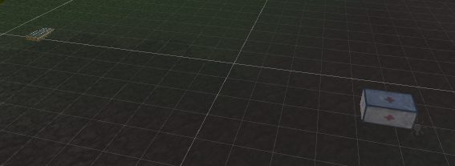

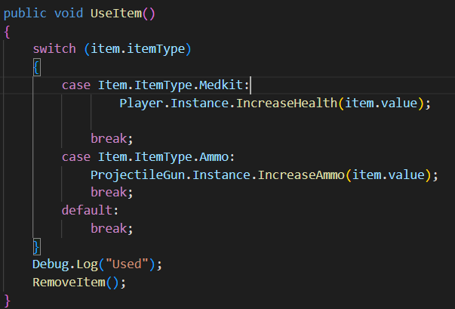

## **Task #5. *High Score in PlayerRefs***

As our defense task we added a high score that is saved in PlayerRefs to keep track of overall highscore throughout the games

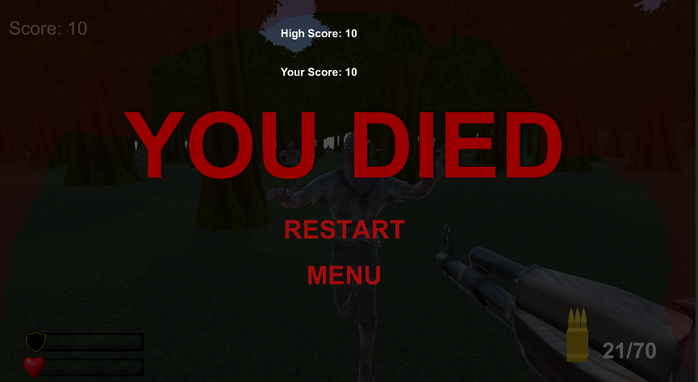

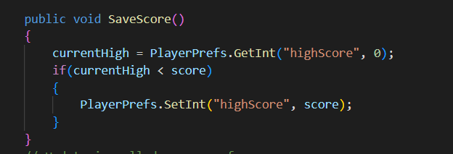

**User's manual** (for the Individual work defence)

**How to play?** Main goal of the game is to find and reach the exit door out of the forest infested with zombies, you can play by running away from the zombies and trying to find the exit or kill the zombies by shooting at them but they can spawn at any time so that only puts some distance between you and them. If you run out of bullets or are low health you can find the areas in the forest with supplies to replenish them

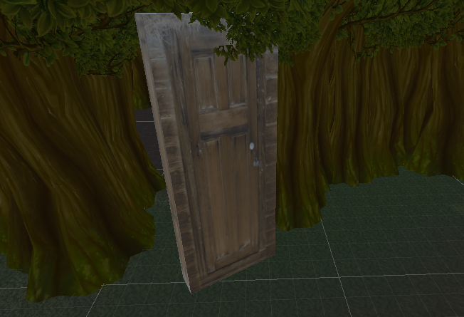



**Descriptions of the rules of the game**.

The rules of the game are simple, find the door that leads you out of the forest. You can run attack try to hide from the enemies.

**Descriptions of the controls / keys.**

Player controls:

A – goes left

S – goes back

D – goes right

W – goes forward

R – Reloading

E – Open inventory

ESC – Open pause menu

C – takes an item

Mouse(left button) – shoot

# **Literature list**

1. Source #1. *https://moodle.ktu.edu/pluginfile.php/418537/mod_resource/content/0/lecture%2011.pdf*
2. Source #2. *https://moodle.ktu.edu/pluginfile.php/418538/mod_resource/content/0/lecture%2010.pdf*
3. Source #3. *https://moodle.ktu.edu/pluginfile.php/413678/mod_resource/content/0/lecture%209.pdf*

# **ANNEX**

All source code is contained in this part.